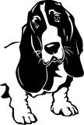
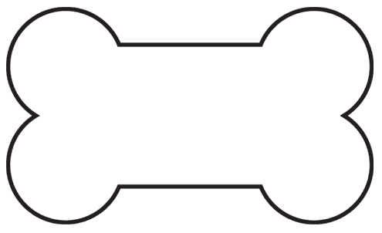
Welcome to the 2017 Season of the
Kidz Klub
Nashville Demonstration Organic Garden (NDOG) and the NDOG’s Kidz Klub

In addition to our “adult” garden, we will also have a garden just for kids (and for those who are kids at heart). The NDOG Kidz Klub Garden consists of raised garden beds and is handicap accessible.

Our goal is to introduce gardening as a fun, hands-on experience through being in touch with nature and learning gardening skills.

Kidz Klub members (ages 3 – 10) will experience the joys of digging in the dirt, selecting plants for the garden, planting and watering them and watching them grow. Through fun crafts and learning activities, Kidz Klub members will also learn about bees, insects and butterflies and their importance to the garden. We will even learn about earthworms and visit and feed them in their home! Note Kidz Klub volunteers may request the parent/guardian remain with children who are under age 4.

NDOG Kidz Klub Members – Join in on all the fun: Meet at Howard County Farmers’ Market on Friday mornings, May 12 – August 11, from 8:00 am to 9:30 am. (Don’t be late – you will not want to miss out on any of the fun!) Parents are welcome to attend or shop at the Farmers’ Market and check out the weekly demonstrations at NDOG.

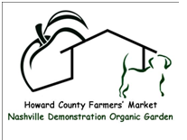
Suggestions – sunscreen, a sun hat or sun glasses, comfortable clothing and shoes, and a water bottle with name on it. We will get dirty!!!!
Inclement weather –
Kidz Klub may be cancelled.
2017
Kidz Klub
NDOG Kidz Klub Application

Child’s Name_____________________________________

Child’s Age____ 2017-18 Grade___ Birthdate__________

Allergies/Medical conditions (please update as needed): _________________________________________
__________________________________________________
__________________________________________________

Parent’s / Guardian’s Name_____________________________________________

Cell phone #________________________________________

Are you the parent of this child? If not, please explain. ___________________________________________________

Parent agrees to remain on the grounds of the Howard County Farmers’ Market or NDOG and to be available at all times the child is in attendance at NDOG Kidz Klub in case of emergency, bathroom needs, behavior issues, etc. All children will be signed in and out of each session and will remain at NDOG Kidz Klub until picked up by the parent/guardian.
_______________________________
Signature /Date

